GROUP 11 REPORT

DATABASE GROUP PROJECT

William Cham Zhang | Takami Nakashima | Gorkem Sari | Enes Sertkan | Nanami Waku

101381972 | 101395226 | 101266503 | 101403883 | 101371241

**CRN-81089-202103**

**THE CONCEPTUAL DATA MODEL**

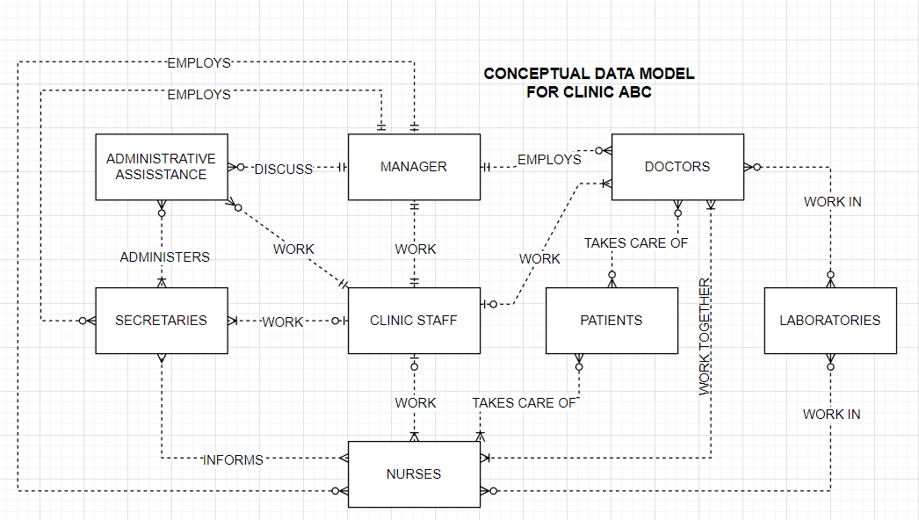

**Logical/Physical ER model**

